CS560 Knowledge Discovery and Management

Feb. 13 (Th), 2014

**LAB - 3**

**Report on Mashup Application, Cloudera, Mahout**

**BY**

**SIVA KRISHNA KOMMINENI**

**16104984(sk7x9)**

**Task 1:** Creation of a mashup Application.

The Mashup application consists of 4 applications done using the mobile client application using the existing web services

1.Geolocation Service – It helps in identifying the current location where you are located.

2.Direction Service – It helps in identifying the direction between two places A & B.

3.Image – helps in displaying the image as per our required specification

4. Audio – Plays audio using the play button and we can also pause it using pause button.

These all are implemented using the mobile client application and the screen shots are attached as below.

It comprises of Html,Jsfiddle,Css.The source code for all this is enclosed in the repository.

**Url** describing this application is - <http://jsfiddle.net/sk7x9/xYLFc/>

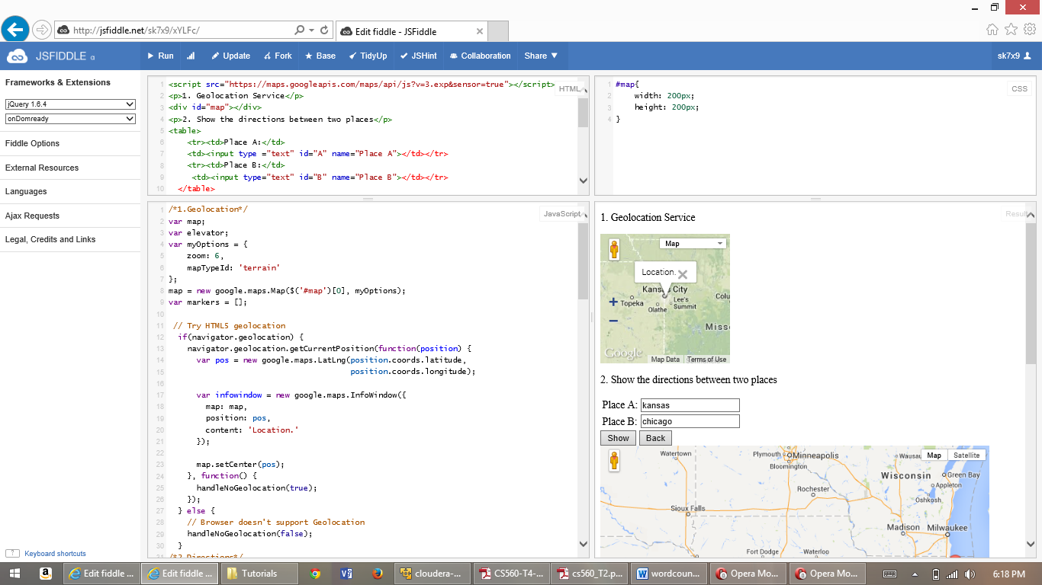

Screen shots using the opera mobile emulator explaining the output are enclosed below.

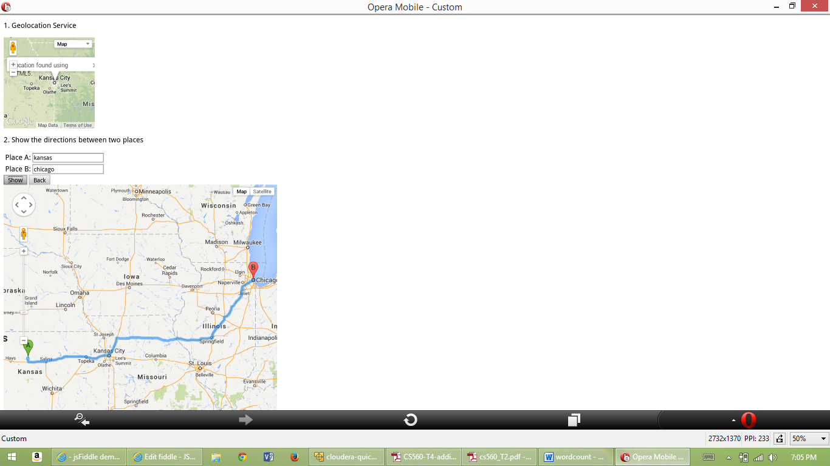



**Task 2 :** Download the cloudera 4.5 image and the download the VM player 6 and then map the image that you have downloaded to the VM player.

Download the wordcount example and then unzip it, run it using hapood command and you will be able

to see the results in the output file as follows.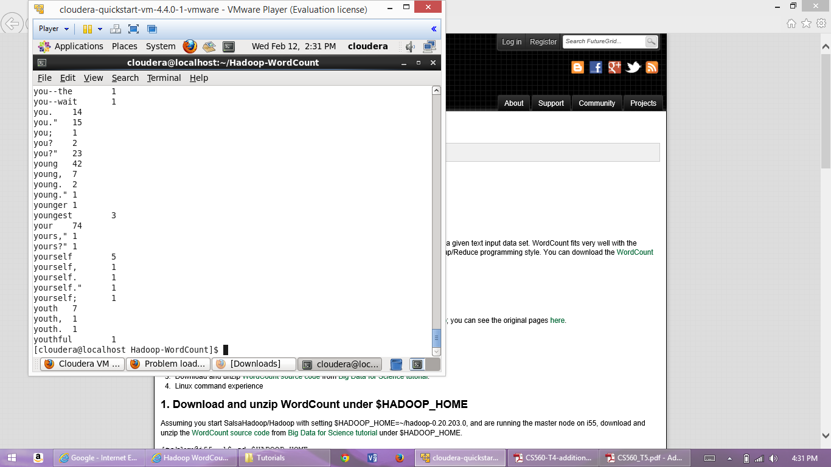

**Task 3:** To install Mahout first download the maven 3.0.5 and then archive it then set the environment variables, path variables and then run maven.

Check for the maven versions as follows.You will be able to see the paths and maven versions installed as shown below.

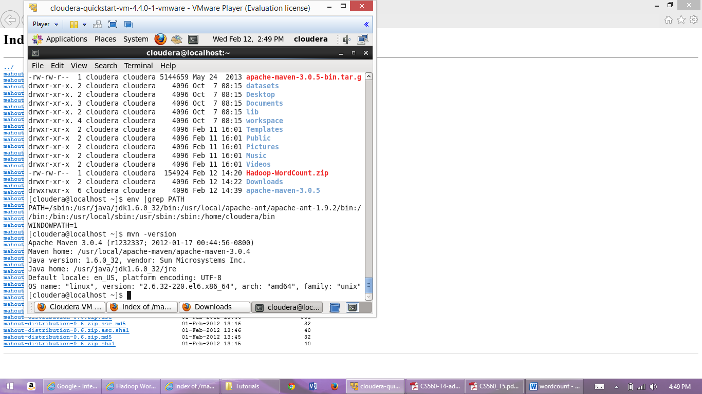

Later download mahout 0.6 and unzip it .download the mahout distribution pom.xml then copy this pom.xml file and then place it in the mahout folder and run the final command to install mahout.

Upon Successful installation it shows Build success as follows.

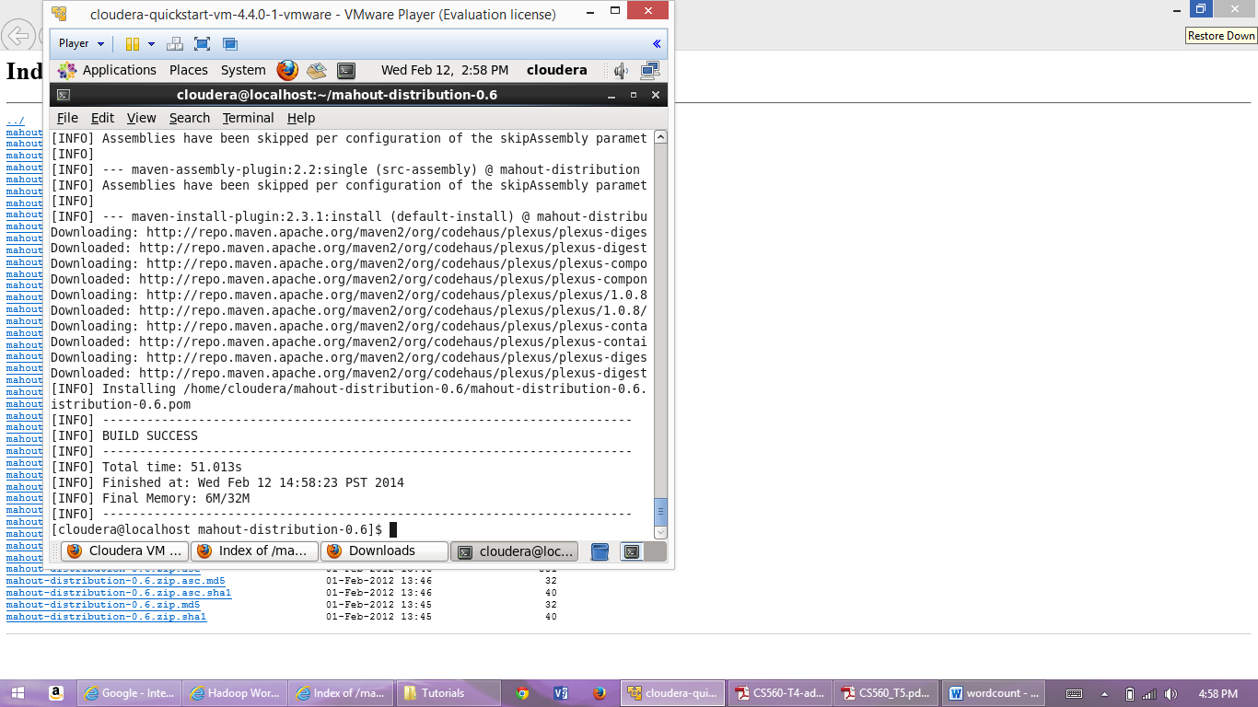

Then run the examples present there using the commands.

Run the Naivebayes by clicking the choice 1 as shown below.

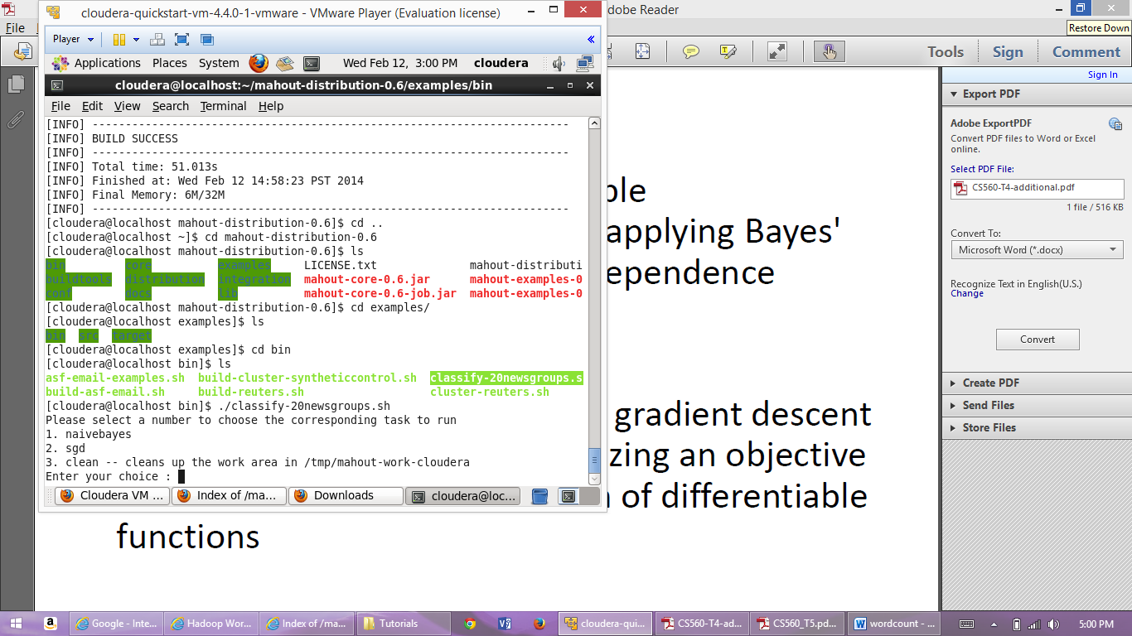

Finally it displays the result as follows after executing the example. Verify the results.

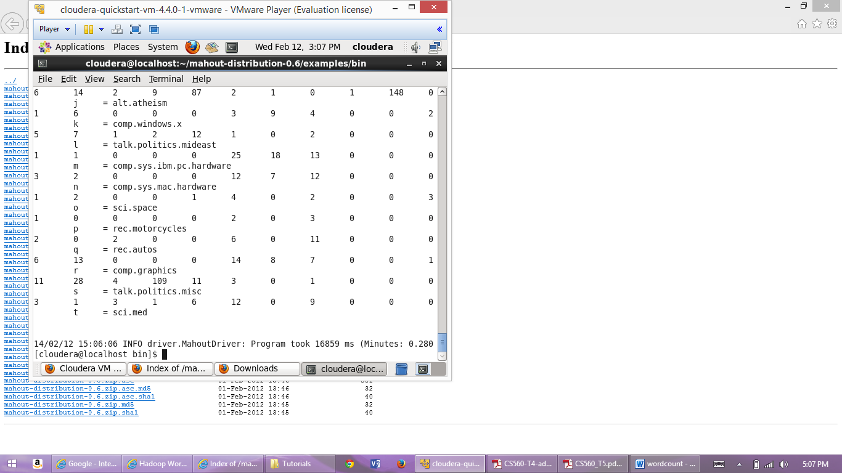

**Task 4:** TheReport on all this applications Enclosed

**Task 5:** Github url is posted in Lab3 site.